Use-Case Realization Report (Analysis)
Coin Input and Select Brand

Issue 3.0
Revision History
Date | Issue | Description | Author
12 July 2000 | 1.0 | First Issue | Howard Russon
2 August 2001 | 2.0 | Revised for MTech Unit 3 in 2001 | Howard Russon
21 July 2004 | 3.0 | Revised for MTech Unit 3 in 2004 | Howard Russon

Table of Contents
1. Brief Description 4
2. Flow of Events 4
2.1 Standard Flow 4
2.1.1 Select Drinks Brand 4
2.1.2 Enter Coins 4
2.1.3 Store Coins 5
2.1.4 Terminate Transactions 6
2.2 Exceptions 7
3. Interaction Diagrams 8
3.1 Collaboration Diagram: Select Drinks Brand 8
3.2 Collaboration Diagram: Enter Coins 9
3.3 Collaboration Diagram: Store Coins 10
3.4 Collaboration Diagram: Terminate (Maintainer Logs-in) 11
3.5 Collaboration Diagram: Terminate (Fault is Detected - Change) 12
3.6 Collaboration Diagram: Terminate (Fault is Detected - Storing Coins) 13
3.7 Collaboration Diagram: Terminate (Fault is Detected - Dispense) 14
3.8 Collaboration Diagram: Terminate (Customer Terminates Transaction) 15
4. Participating Objects 15
5. Class Diagrams 17
5.1 Class Diagram: Coin Input and Select Brand (Main) 17
5.2 Class Diagram: Coin Input and Select Brand (Stores) 18
6. Derived Requirements 18

Use-Case Realization Report
Coin Input and Select Brand

Brief Description
This use case enables the Customer to buy drinks from the vending machine by selecting a brand from those available, and then entering coins to pay for the selection. Invalid coins will be returned. Provided the required amount of money is entered, the selected brand will be dispensed to the customer. Change will be given if more money than the price of the drink is entered. The Customer will be permitted to terminate the purchase prior to the selected brand being dispensed. In such cases, the money entered will be refunded.

Flow of Events
The standard flow of events for this use case and any exceptions are described in the following subsections. The events are described in terms of Actors and Analysis Objects.

Standard Flow
This use case carries out four functions: selecting brands; entering coins; storing coins; terminating transactions. It also uses other use cases to dispense drinks, give change and give refunds. The use case is described below.

Select Drinks Brand
The flow of events is shown in section 3.1 and described as follows:
- The Customer selects a drink by pressing an active selection button on the Drink Selection Box in the Customer Panel. When this occurs, the DrinkSelected operation of the Drink Selection Box will use the StartTransaction operation of the Transaction Controller, by providing the identification of the drink choice.
- The StartTransaction operation of the Transaction Controller will use operation GetItem of the Drinks Store to get the Drink Store Item corressponding to the drink choice of the customer. The Transaction Controller will then get the Drinks Brand held by the Drink Store Item by using operation GetBrand of the Drink Store Item.
- Then, the StartTransaction operation of the Transaction Controller will use operation GetPrice of the Drinks Brand to get the price of selected drink.
- Then, the Transaction Controller will instruct the Change Giver to reset the Refund/Change Tray Display by using operation ResetChange of Change Giver. The Change Giver will accomplish this by using operation InitialDisplay of Refund/Change Tray Display.
- Then, the Transaction Controller will use operation ResetCan of the Dispense Controller instructing it to reset the Can Collection Box. The Dispense Controller will accomplish this using operation InitialDisplay of Can Collection Box.
- Then, the Transaction Controller will instruct the Dispense Controller to deactivate the Drink Selection Box to disallow the selection of further drinks when the transaction is in progress. This will be accomplished using operation AllowSelection (with disable indication) of the Dispense Controller. The Dispense Controller will use operation Deactivate of Drink Selection Box to accomplish this.
- The Transaction Controller will then initiate the entry of Coins by the Customer. This is done by instructing the Coin Receiver to prepare for receiving Coins by using operation StartReceive. The Coin Receiver will achieve this by instructing the Coin Input Box to become activated by using operation Activate.

Enter Coins
The flow of events is shown in section 3.2 and described as follows:
- The Customer enters a Coin by pressing a button on the Coin Input Box. When this occurs, the Coin Input Box will use its operation CoinEntered to send the weight of the Coin to the Coin Receiver using operation ReceiveCoin of the Coin Receiver.
- The ReceiveCoin operation of the Coin Receiver will do the following:
- Use operation Deactivate of the Coin Input Box to deactivate further coin input.
- Determine the value of the Coin entered by instructing the Cash Store to do this by using operation FindCoin. The Cash Store will find the weight of each of the Coin types that it holds, using operation GetWeight of each Coin object, and compare each weight with the weight of the entered Coin.
- If the Coin type is found (ie: it is a valid Coin), then a reference to the Coin object will be returned to the Coin Receiver. If the value of the Coin cannot be determined, then the Coin Receiver will be informed that an invalid Coin was entered.
- If a valid Coin is received, the Coin Receiver will use operation GetValue (of the Coin) to find its value, and then add its value to the total value of the Coins entered during the current transaction. The new total value will be sent to the Total Money Inserted Display for display on the Customer Panel. Operation Update of the Total Money Inserted Display will accomplish the display task.
- If an invalid Coin is received, the Coin Receiver will display COIN NOT VALID on the Invalid Coin Display and also display a Coin shape labeled Invalid on the Refund/Change Tray Display. To accomplish this, these objects will use operations DisplayCoinInvalid and DisplayInvalidCoin respectively.
- When valid coins are inserted, the Coin Receiver will inform the Transaction Controller about the receipt of a coin and the total money inserted so far, by using operation ProcessMoneyReceived of the Transaction Controller. The ProcessMoneyReceived operation will determine whether the total money inserted is less than the price of the drink brand selected. If more money is required then the Coin Receiver will be instructed to continue receiving coins. For this, operation ContinueReceive of the Coin Receiver will be used. The ContinueReceive operation will activate the Coin Input Box so that further Coins can be entered. Coin Input Box will use operation Activate to accomplish this.
- When the total value received is greater or equal to the price of the drink selected, the Transaction Controller will use its internal operation CompleteTransaction to dispense the drink, give change (if necessary) and store the coins:
- To dispense the drink, the CompleteTransaction operation will further use the DispenseDrink operation of the Dispense Controller. The drink dispense flow of events and operations are described under the Dispense Drink use case.
- The CompleteTransaction operation of the Transaction Controller will calculate the change amount to be given and provide it to the Change Giver. The change giving flow of events and operations are described under the Give Change use case.
- If a fault is detected, while dispensing a drink or issuing change, the Transaction Controller will trigger the internal operation, TerminateFault. This is described below in the section entitled: "Terminate Transactions".
- The Coins entered will then be stored in the Cash Store. This is described below in the section entitled "Store Coins".
- Finally, the Transaction Controller will instruct the Dispense Controller to update the Drink Selection Box so that further Customer transactions can occur by using operation AllowSelection. This is achieved for each brand as follows:
- Operation GetItem of Drinks Store will be used to get a reference to the Drink Store Item that corresponds to the brand.
- Operation GetQuantity of Drink Store Item will be used to determine the current stock level of the brand.
- Operation SetState of the Drink Selection Box will be used to activate or deactivate the buttons according to the stock level.

Store Coins
The flow of events is shown in section 3.3 and described as follows:
- When the drink has been dispensed and the change has been issued, the Transaction Controller, using operation CompleteTransaction, will inform the Coin Receiver to store the coins received into the Cash Store. The Coin Receiver will use its operation StoreCash to accomplish this.
- The Coin Receiver will then initiate the storage of the entered Coins one at a time. The Cash Store will use operation Store to store each Coin as follows:
- Each Coin held by the Coin Receiver will be sent to the Cash Store by using its Store operation.
- The Cash Store will add the Coin received to the total number held of that denomination by using operation AddCoin of the Coin.
- The Coin Receiver will then re-set its coin input store attributes, and reset the Total Money Inserted Display (to display 0.00) by using operation Update of the Total Money Inserted Display (with a zero value as display data).
- The Coin Receiver will then instruct the Store Controller to update the coin denomination display on the Machinery Simulator Panel by using operation DisplayCoinQuantity of Store Controller. To achieve this, the Store Controller will do the following for each denomination held:
- Use operation GetQuantity of Cash Store to determine the number of Coins of the denomination held. This operation in turn uses operation GetQuantity of the respective Coin object.
- Use operation Update of the Cash Store Display to display the value.

Terminate Transactions
Customer transactions can be terminated if the Maintainer logs-in, or if a fault is detected while dispensing a drink or giving change, or if the Customer presses the Terminate Button on the Customer Panel. The flow events is shown in sections 3.4-3.8 and described in the following sections.

Maintainer Logs-in
If the Maintainer logs-in successfully, any ongoing Customer transaction will be terminated and new transactions are suspended until the Maintainer logs-out. When the Transaction Controller is informed that the Maintainer has logged-in, it uses operation TerminateTransaction to perform the following:
- If there is no transaction in progress then the Drink Selection Box will be deactivated by using its operation Deactivate.
- If there is a transaction in progress but coin input is not yet complete, then the Coin Receiver will be instructed to stop coin input (disable Coin Input Box) by using operation StopReceive of the Coin Receiver. It will achieve this by operation Deactivate of Coin Input Box.
- The TerminateTransaction operation of the Transaction Controller will then get the total money inserted by the customer so far from the Coin Receiver using the operation GetTotal. If the total money inserted is non zero, refunding money to the customer is initiated by using operation RefundCash of the Coin Receiver. This is described under use case Refund Money.

Fault is Detected
If faults are discovered while storing coins, dispensing a drink or giving change, the current transaction will be terminated and Customer transactions will not be able to resume until the Maintainer next logs-out of the system maintenance facility. When faults are detected messages will be sent to the Transaction Controller. It will then use operation TerminateFault as follows:
- If a fault is detected during the process of giving a change, then
- The Drink Selection Box will be deactivated by using its operation Deactivate .
- The Coins entered to date will be stored in the Cash Store by using operation StoreCash of Coin Receiver (as described under "Store Coins" in this use case).
- If a fault is detected during the process of storing the Coins, then the the Drink Selection Box will be deactivated by using its operation Deactivate.
- If a drink has not been successfully dispensed, the Coin Receiver will be instructed to initiate the giving of a refund to the Customer of all money entered during the transaction by using operation RefundCash of Coin Receiver. This is described under use case Refund Money.

Customer Terminates Transactions
If the Customer terminates the current transaction by pressing the Terminate Button on the Customer Panel, then the TerminateRequest operation of the Terminate Button will request the Transaction Controller to process the termination request. For this, operation CancelTransaction of the Transaction Controller will be used. The CancelTransaction operation will perform the following:
- If there is no transaction in progress or coin input has been completed then the request will be ignored.
- If coin input is not yet complete, then the following will occur:
- The Coin Receiver will be instructed to stop coin input (disable the Coin Input Box) by using its operation StopReceive.
- The value of money inserted by the customer (until the termination request) will be obtained from the Coin Receiver by using the operation GetTotal.
- If the total money entered is greater than zero then the Coin Receiver will be instructed to initiate the giving of a refund to the Customer of all money entered during the transaction by using operation RefundCash of Coin Receiver. This is described under use case Refund Money.
- The Dispense Controller will be instructed to allow selection of drinks for further dispense transactions. The Dispense Controller will use operation AllowSelection to accomplish this (as described in the section entitled "Enter Coins").

Exceptions
The following exceptions have been identified:
- Maintainer Instruction to Terminate Transactions. This exception is described in detail in section 2.1 under Terminate Transactions.
- Maintainer Instruction to Commence Transactions. This exception is processed under the System Maintenance use case.
- Customer Terminates Too Late. As described in section 2.1 under Terminate Transactions, if the Customer tries to terminate a transaction after completing the entry of Coins, then the terminate request will be ignored.
- Fault is Detected. This exception is described in detail in section 2.1 under Terminate Transactions.
- No Drinks Brand Selected. If no brand has been selected then the Coin Input Box will be deactivated, and hence the Customer will not be permitted to enter Coins.
- Drinks Brand Not In Stock (1). If a Drinks Brand is selected by the Customer that is displayed as out of stock, then the button will be deactivated and hence selection will be ignored.
- Drinks Brand Not In Stock (2). If a brand is selected by the Customer that is displayed as in stock but is actually out of stock, then this will be detected by the Drinks Store (through use case Dispense Drink) and will cause a fault message to be sent to the Transaction Controller. This will lead to the termination and suspension of Customer transactions as described in section 2.1 under Terminate Transactions.

Interaction Diagrams

Collaboration Diagram: Select Drinks Brand
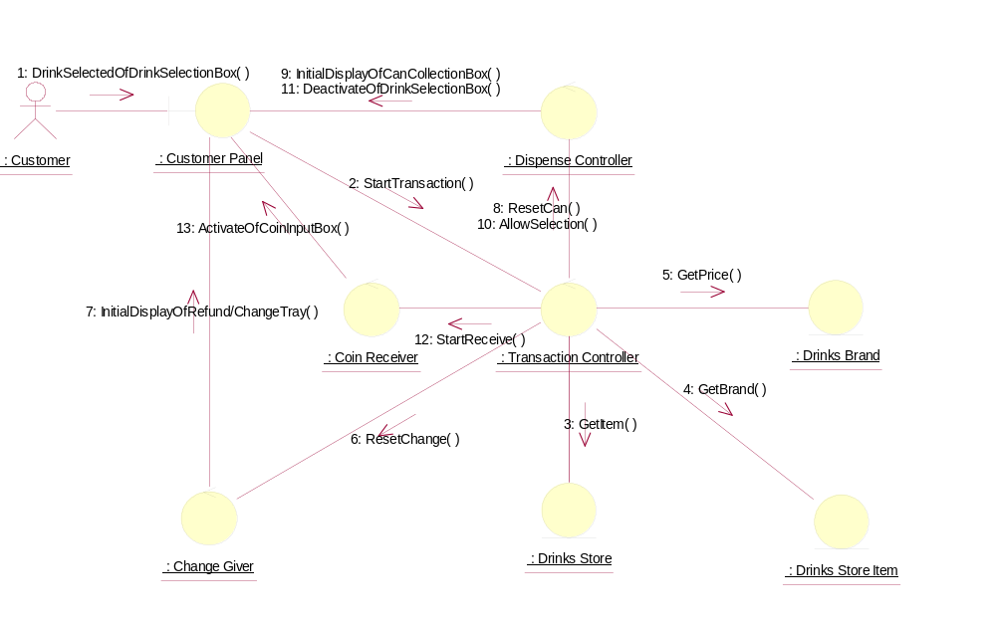

Collaboration Diagram: Enter Coins
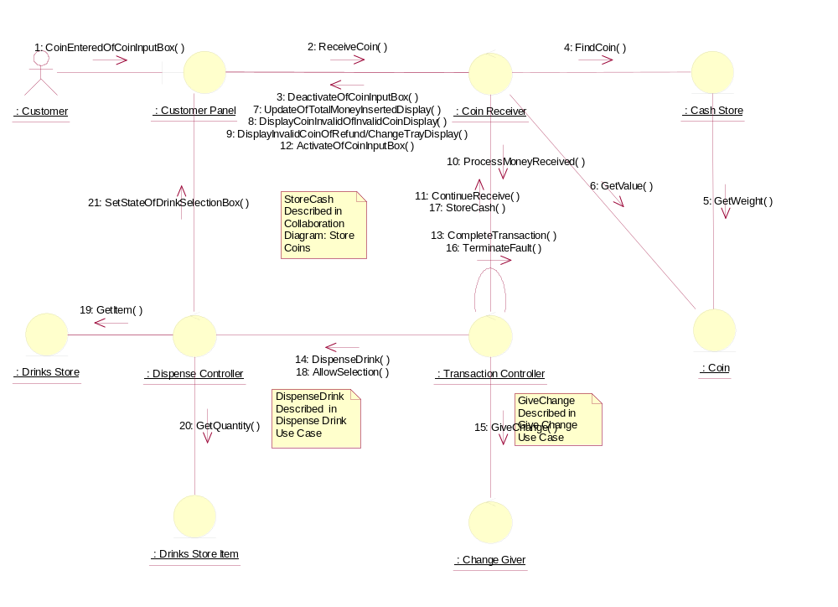

Collaboration Diagram: Store Coins
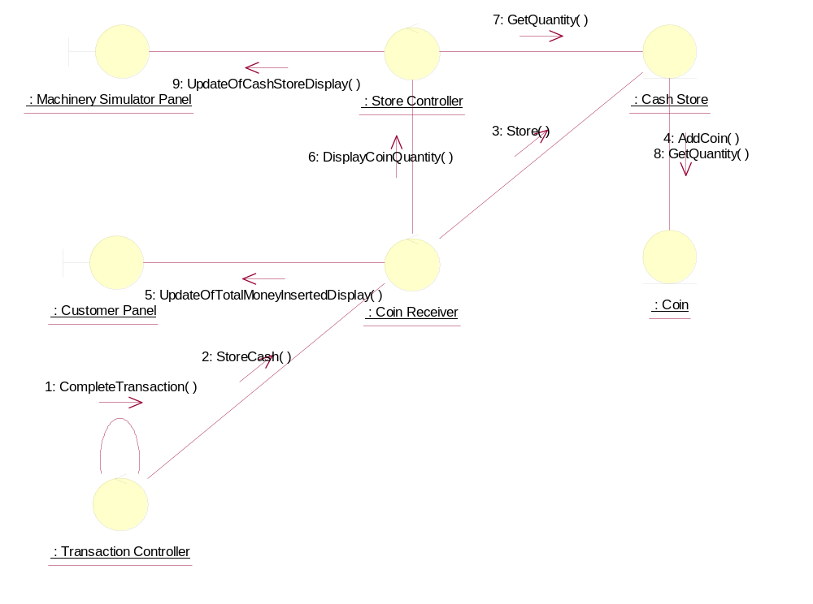

Collaboration Diagram: Terminate (Maintainer Logs-in)
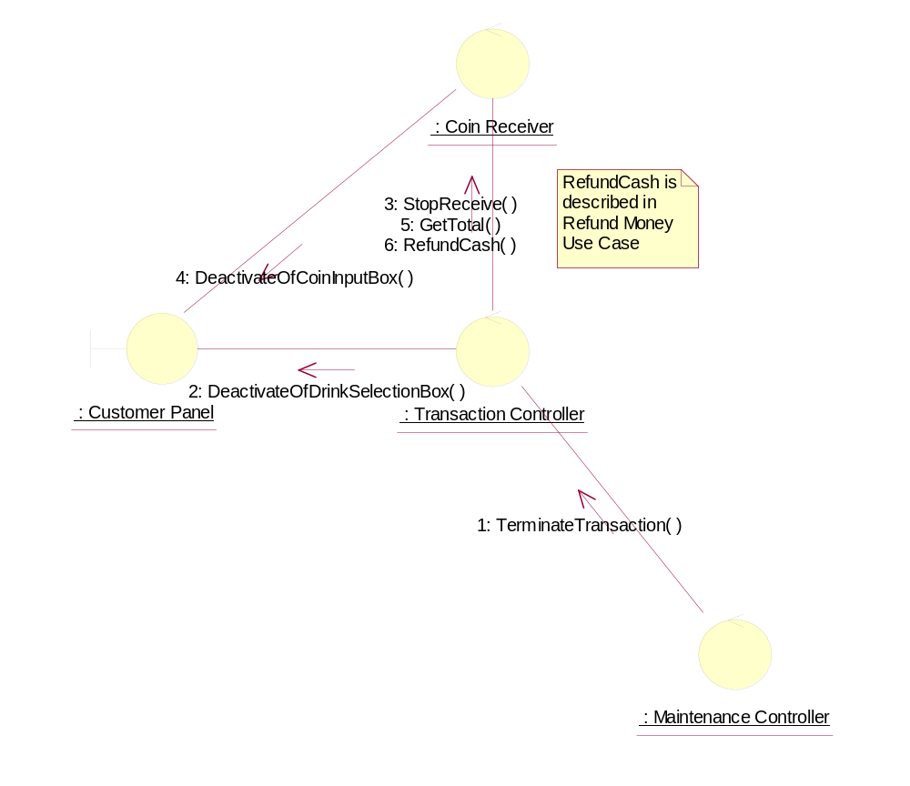

Collaboration Diagram: Terminate (Fault is Detected - Change)
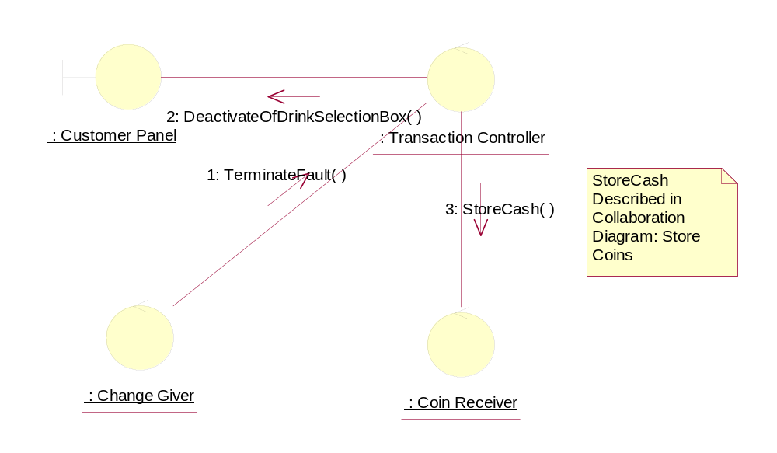

Collaboration Diagram: Terminate (Fault is Detected - Storing Coins)
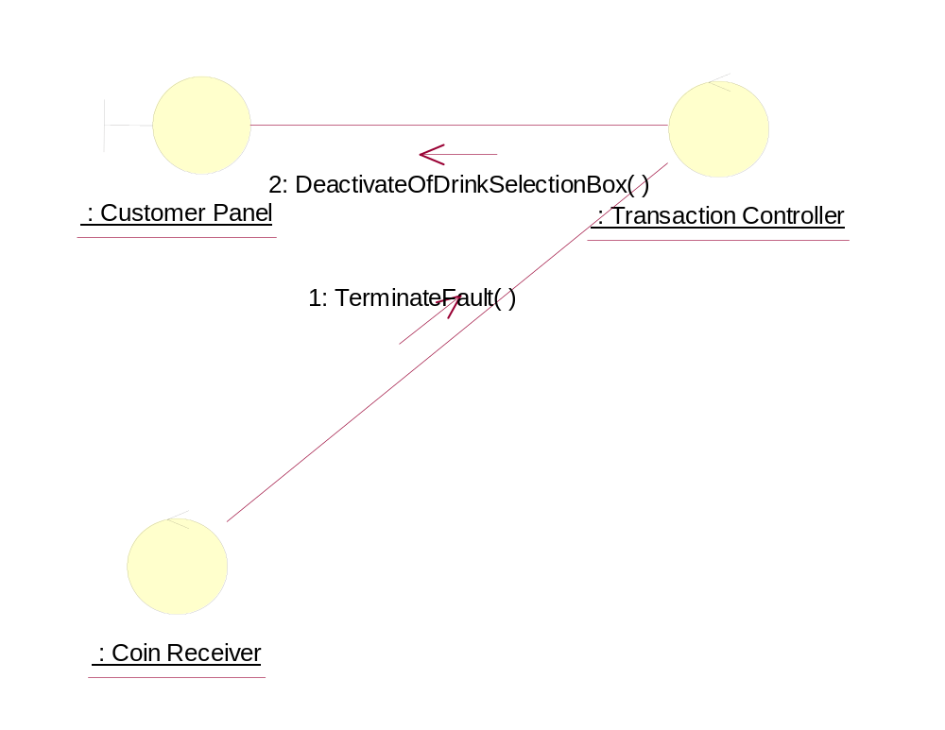

Collaboration Diagram: Terminate (Fault is Detected - Dispense)
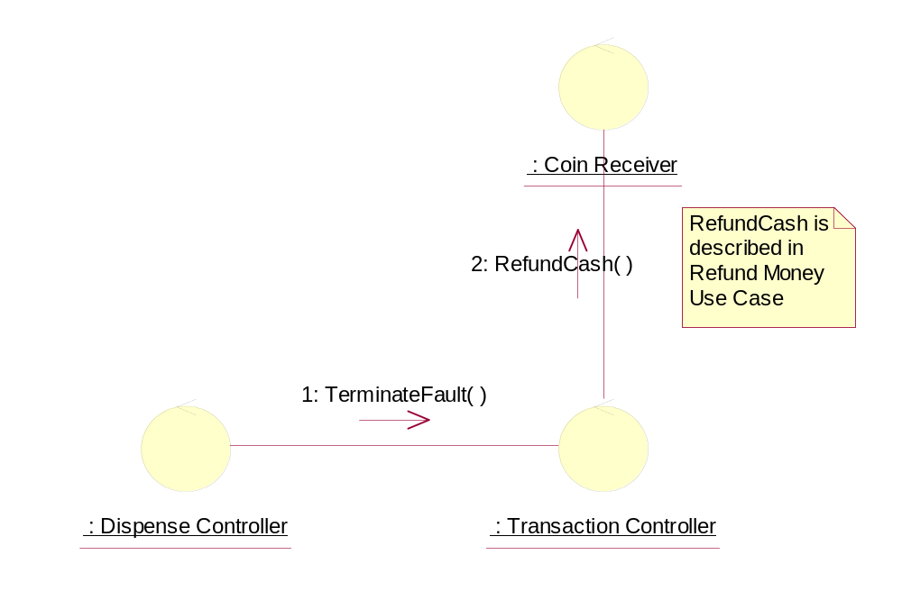

Collaboration Diagram: Terminate (Customer Terminates Transaction)
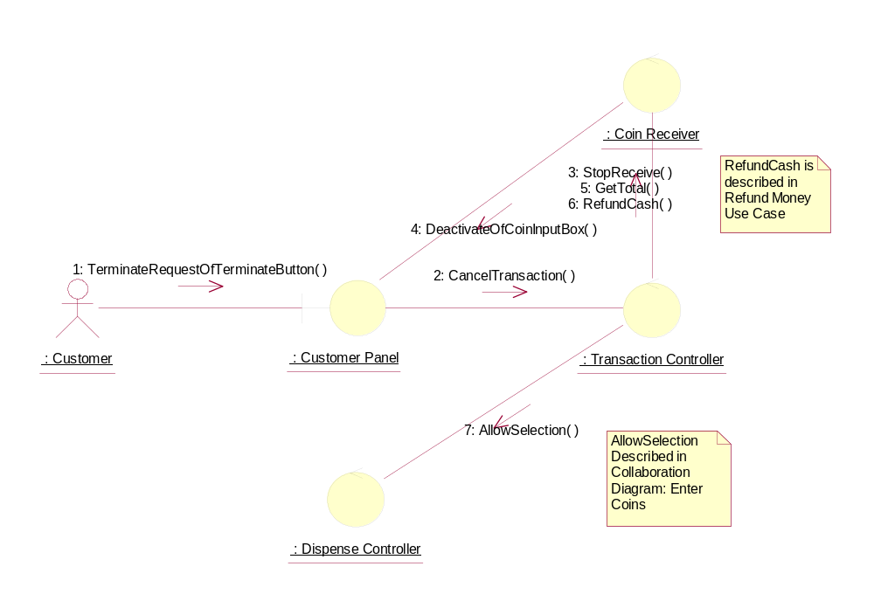

Participating Objects
: Cash Store
This object represents the store of cash in the vending machine.

: Change Giver
This control object manages the giving of change to the Customer.
: Coin
This object stores the weight and value of each type of Coin, and hence enables the machine to recognise each Coin entered.
: Coin Receiver
This control object manages the input and storage of Coins.
: Customer
This actor represents the customer of the vending machine (members of the general public) who would buy drinks-cans from the vending machine.
: Customer Panel
This panel simulates the vending machine's customer interface panel. It will enable the user (the Customer) to:
1 insert coins;
2 select brands;
3 terminate transaction.
It will also provide the following display functions:
1 display total money inserted;
2 indicate coin not valid;
3 indicate no change available;
4 display the value of the change to be collected;
5 display an icon representing the dispensed drink.
: Dispense Controller
This control object is for handling the dispense drink use case.

: Drinks Brand
This entity object stores the name of the drink brand and it's price. There can be as many drink brands as we desire, for a particular configuration.
: Drinks Store
The object is storage, in the vending machine's memory, for the total number of cans of each Drinks Brand held by the vending machine.
: Drinks Store Item
This represents a column of drinks in the vending machine. It can store a drink of any particular brand type.There can be as many drink store items as we desire in the vending machine. This number will be a configurable item for the vending machine.
: Machinery Simulator Panel
This panel simulates the physical actions of the maintainer. It enables the user to:
1 display and enter new values for the number of cans of each Drinks Brand held by the Drinks Store;
2 display and enter new values for the number of Coins of each denomination held by the Cash Store;
3 display whether the vending machine Door is unlocked, and enable it to be locked.
: Maintenance Controller
This control object handles the system maintenance use case.
: Store Controller
This object controls the Change State use case. It mangages changes in Cash Store attributes and the Drinks Store attributes. It also handles the door status. It is also used by the Dispense Drink use case to update the Drinks Store attributes.
: Transaction Controller
This control object coordinates the customer transactions for selection of a drink brand, coin input, storage of coins and termination requests for ongoing transactions.

Class Diagrams

Class Diagram: Coin Input and Select Brand (Main)
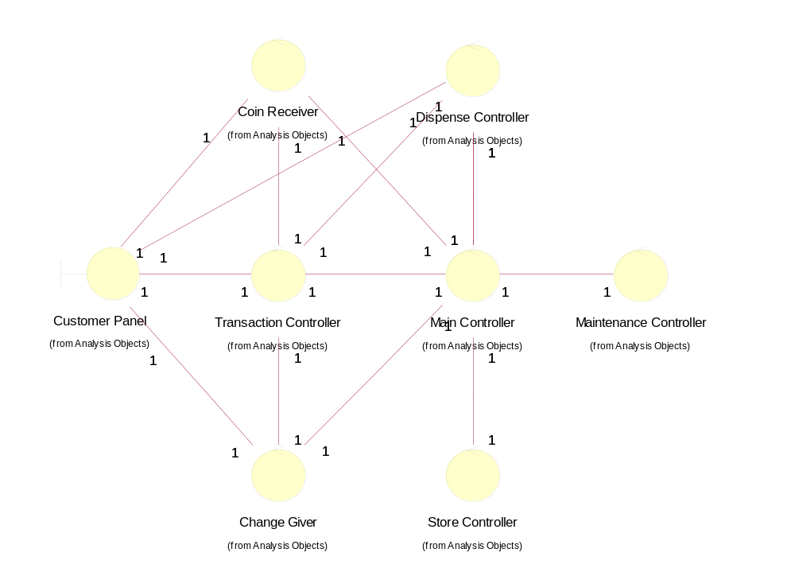

Class Diagram: Coin Input and Select Brand (Stores)
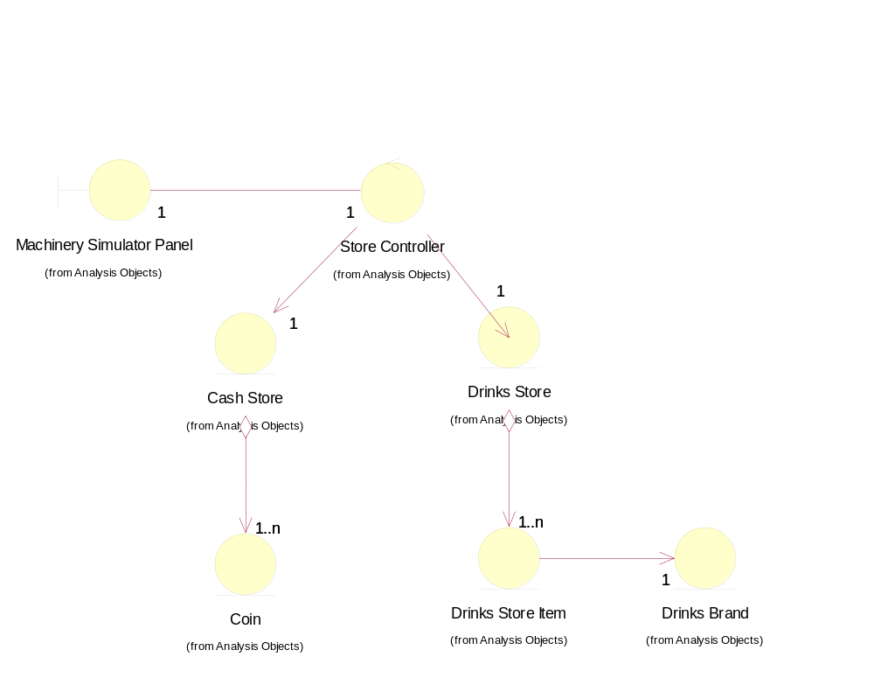

Derived Requirements
There are no special requirements associated with the host implementation. However, in the target implementation, a input slot for entering Coins (which will determine the weight of each Coin entered), and a cash tray for returning Coins will be required.

